Federal Agency for Scientific Organizations
Research Geotechnological Center of Far Eastern Branch of the Russian Academy of Sciences

2nd International Geothermal Conference GEOHEAT
GEOHEAT 2018
First Announcement

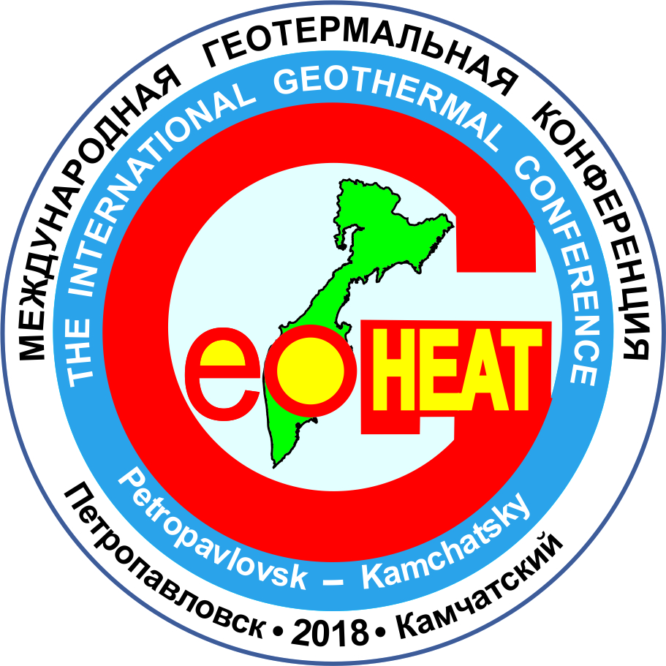

Dates

4 to 7 September 2018

Petropavlovsk-Kamchatsky, Russian Federation

Organizing Committee:
Chair Roman I. Pashkevich Research Geotechnological Center of Far Eastern Branch of Russian Academy of Sciences, Russian Federation

Members
Alibek B. Alkhasov Institute for Geothermal Problems of the Daghestan Scientific Centre of the Russian Academy of Sciences, Russian Federation
Alper Baba Geothermal Energy Research and Application Center, Izmir Institute of Technology, Republic of Turkey
Graeme Beardsmore Hot Dry Rocks, Australian Geothermal Association, Australia
Dornadula Chandrasekharam Department of Earth Sciences, Indian Institute of Technology Bombay, India
Surya Darma Indonesia Renewable Energy Society, Republic of Indonesia
Sergei A. Fedotov Institute of Physics of the Earth of the Russian Academy of Sciences, Russian Federation
Mikhail D. Khutorskoi Geological Institute of the Russian Academy of Sciences, Russian Federation
Vladimir P. Kobolev S.I. Subbotin Institute of Geophysics of the National Academy of Sciences of Ukraine, Ukraine
Thomas Kohl Institute of Applied Geosciences, Karlsruhe Institute of Technology, Federal Republic of Germany
Margaret Krieger International Geothermal Association, Federal Republic of Germany
John W. Lund Geo-Heat Center, Oregon Institute of Technology, United States of America
Peter Meier Geo-Energie Suisse, Switzerland
George Melikadze Research Center of Hydrogeophysics and Geothermy, Institute of Geophysics, Ivane Javakhishvili Tbilisi State University, Georgia
Abdulvahab Mukhtarov Department of Geothermics, Geology and Geophysics Institute of Azerbaijan National Academy of Sciences, Republic of Azerbaijan
Mike O’Sullivan Department of Engineering Science, University of Auckland, New Zealand
Zhonghe Pang Institute of Geology and Geophysics, Chinese Academy of Sciences, Peoples Republic of China
Yuri A. Popov Skolkovo Institute of Science and Technology, Russian Federation
Árni Ragnarsson Iceland GeoSurvey, Iceland
Jesus Rueda Asociación Colombiana De Estudiantes De Geociencias, Republic of Colombia
Sheng-Rong Song Department of Geosciences, National Taiwan University, Taipei
Saulius Sliaupa Laboratory of Bedrock Geology, Institute of Geology and Geography, Republic of Lithuania
Yoonho Song Korea Institute of Geoscience and Mineral Resources, Republic of Korea
Mario-Cesar Suarez-Arriaga International Geothermal Association – Mexican Geothermal Association, United Mexican States
Yuri P. Trukhin Research Geotechnological Center of Far Eastern Branch of Russian Academy of Sciences, Russian Federation
Ernest Tshibalo University Teaching and Learning Development, University of South Africa, Republic of South Africa
Grigori P. Vasiliev Insolar Invest, Russian Federation
Albert Waibel Columbia Geoscience, United States of America
Vladimir I. Zui Belarusian State University, Republic of Belarus

GEOHEAT 2018 is an annual geothermal international conference. The first conference was held in 2017. Twenty-seven papers of the scientists and professionals from 5 countries worldwide (Russia, Germany, New Zealand, Mexico and Taiwan) were presented in a plenary session. The attendants presented twelve scientific and educational institutions, three production companies and one business administration. There were more than 100 registered participants. Four scientific trips were carried out as a part of the conference. The representative of International Geothermal Association participated in the conference.
Goals:
The goals of the conference are to distribute scientific and industrial information concerning current state of geothermal science, technology and industry; to share knowledge and results in theory, methodology, technology and applications of geothermal science; to bring together scientists, researchers, engineers, students and managers interested in geothermal science; to promote geothermal innovations; provide a forum to exchange ideas on the exploration, development and use of geothermal resources; to encourage international communication and collaboration.

Topics for talks, posters, and panel discussions:
- Theoretical Issues of Geothermics and Heat Flow
- Geothermal Resources in Extensional and Compressional Settings
- Geosciences
- Case Studies
- Exploration
- Field Management
- Electricity Generation
- Drilling and Well Bore Flows
- Reservoir Engineering and Numerical Simulation
- Geology of Geothermal Fields
- Geochemistry of Geothermal Fields
- Thermal Properties of Geothermal Fields Rocks
- Low Enthalpy Systems and Direct Use
- Geothermal Heat Pumps
- Geothermal Hydrogen
- Magma Chambers
- Economics

Workshop Location:

The conference venue is in the Research Geotechnological Center of Far Eastern Branch of Russian Academy of Sciences, Petropavlovsk-Kamchatsky, Russia.

Kamchatka is a very unique region of Russia. It is a part of Pacific Ring of Fire (circum-Pacific orogenic belt) and it is washed by cold Okhotsk Sea, Bering Sea and the Pacific Ocean. Petropavlovsk-Kamchatsky is the capital of Kamchatka peninsula. It is a sea-port and one of the most spectacular towns in the whole world. It is a land of Hot Springs and geysers, volcanoes and valleys with lush vegetation.
Kamchatka is a zone of modern volcanism. It has about 30 active volcanoes, about 300 extinct and destroyed volcanoes, more than 2500 cones, a great number of cold mineral and thermal hot springs and geysers. The Mutnovsko-Gorely Group is located about 80 km south of Petropavlovsk-Kamchatsky on the south side of Avacha Bay. Mutnovsky volcano has the one of the world's largest fumarole fields; and it is one of the most active volcanoes in Kamchatka. Mutnovskaya Geothermal Power Station was built at the foot of this volcano.
Flora and fauna are very rich and unique. There are some giant species (up to 3-3.5 m) which grow on a rich volcanic soil. The fauna includes 170 species of birds and 60 species of mammals. Beside numerous rivers, waterfalls and lakes Kamchatka has enormous reserves of fresh water. Kamchatka’s rivers are a spawning place for one of the world largest populations of salmon.
September in Kamchatka is a symphony of colour. It is a beneficial and exciting time to travel around the peninsula. In September there are no permanent fog, rain and slush. The weather is splendid, the temperature is comfortable.
The Petropavlovsk Kamchatsky airport is about 20 km from city border in Yelizovo. Most visitors arrive here from Moscow, but there are flights via Vladivostok and Khabarovsk.

Important Dates and Deadlines:

Registration Letter and Abstracts Submission (the abstract text is limited to 200 words):

January 15, 2018

Notification of Abstract Acceptance

February 1, 2018

Second Announcement and Preliminary Agenda (with the information about plenary session or/and sections):
February 15, 2018

Full Papers Submission for Publication (papers should be limited to a maximum length of 5000 words):
March 1, 2018

Notification of Full Papers Acceptance:
April 1, 2018

Final Agenda:
July 1, 2018

Please, send your registration letter to e-mails: geoheat2018@yandex.ru, nigtc@kscnet.ru, pashkevich@kscnet.ru
In your registration letter would you be so kind to give the information as follows:

1 | First name, Family name
2 | Country and city of residence
3 | Affiliation
4 | Occupation
5 | Degree
6 | Contact telephone number  Mobile number  Fax
7 | E-mail
8 | Postal address
9 | Brief bio
10 | Paper title
11 | Abstract, 1-2 pages
12 | Presentation type:  Oral  Poster  Panel discussion
13 | Major theme
14 | Willingness for scientific field trips

Registration Fee is free of charge

Contact
Mailing Address:
Research Geotechnological Center, Far Eastern Branch of Russian Academy of Sciences, Severo-Vostochnoye shosse, 30, Petropavlovsk-Kamchatsky, 683002, Russian Federation.
Phone: +7(415-2) 495-435
Fax: +7(415-2) 495-435
Director
Roman I. Pashkevich
E-mail: geoheat2018@yandex.ru, nigtc@kscnet.ru, pashkevich@kscnet.ru

Proceedings
Full papers presented at the Conference will be published in electronic form (CD) and in print by the beginning of the conference after the peer review.

Accommodation
Accommodation and hotel booking is made by the Conference participants personally. Hotels information is presented on the https://www.booking.com/city/ru/petropavlovsk-kamchatskiy.ru.html?aid=356993;label=gog235jc-hotel-ru-ru-adacha-unspec-ru-com-L%3Aru-O%3AwindowsSxp-B%3Afirefox-N%3AXX-S%3Abo-U%3Ac-H%3As;sid=f6e01b94faff1435fbd6c1bc50e48624;breadcrumb=hotel&

Official languages
The official language of this conference is English. Speaker can do oral presentation either in Russian or English. Those speakers, who can report both in English and Russian but prefer to speak one of these languages, should deliver a presentation in the format of power point both in English and Russian.
Speakers who will do oral presentation in English and haven’t the possibility to do it in Russian should deliver a presentation in the format of power point in English.

Instructions for abstract submissions
- Submit your abstract in Microsoft Word format (.doc).
- Abstracts are to be written in English only. All presentations will be in the English language.
- The authors’ names and institutions (including address) should be included in the abstract, beneath the title.
- The title of the abstract should be typed in 12-point font.
- The presenting author’s email address must be included.
- The abstract should have a maximum of 200 words
- The abstract for oral and poster presentations should be structured using the following headings: Objective, Methods, Results, Conclusions, and Keywords (no more than four keywords).
- The abstract should be as informative as possible.
- Standard abbreviations such as: XRF, etc., may be used. Others should be described in full when first mentioned followed by the abbreviation in parenthesis.
- Do not include tables, photographs, figures or references in your abstracts.
- Include a one-paragraph bio of yourself with the abstract submission.
Visa
The documents for visa application will be prepared. Participants should send passport photocopy to e-mail: geoheat2018@yandex.ru, nigtc@kscnet.ru, pashkevich@kscnet.ru as soon possible. Then invitation-letter for visa arrangement to the Russian Federation will be sent.
The following information is necessary to make visa arrangement:
1) the copy of your passport;
2) which cities will be better for you to obtain an invitation letter for further visa processing:
3) the state and the city of your birth;
4) the state and the region of your permanent residence;
5) full name of your place of work;
6) full address of your place of work;
7) your position in your organization;
8) through what Russian cities will you get to Petropavlovsk-Kamchatsky;
9) the completed registration form with the title of your report.
This information should be delivered by 1st May, 2018.

Scientific field trips
You can visit Mutnovsky hot springs, geothermal field and GeoPP located
120 km South-West from Petropavlovsk-Kamchatsky city. Mutnovsky GeoPP is the largest one in the Russian Federation. We can offer you a helicopter trip to the Geyser Valley or a flight to the Avacha volcano, a trip to the Malkinskoe and Ketkinskoe fields of thermal water and ethnic settlement Kaynyran.

Agenda
Preliminary agenda will be sent with the Second Announcement by 15th February, 2017. There will be the information about plenary session or/and sections and dates of pre-conference scientific trips.
Final agenda will be presented by 1st July, 2018.

Oral and Poster Presentations
Material may be presented in one of the following presentation types:
– Oral
– Poster

Terms, conditions and rates
All terms, conditions, dates and rates are subject to change (without any other notifications).

